
IPV6 ENTERPRISE MIGRATION AND SECURITY HARDENING FRAMEWORK
A CAPSTONE PROJECT REPORT
A Capstone Project Report submitted in partial fulfilment of the requirements for the Course of
[Course Code & Course Name]
to the award of the degree of
BACHELOR OF TECHNOLOGY
IN
ELECTRONICS AND COMMUNICATION ENGINEERING
Submitted by
DHARSHAN K R (192412096)
Under the Supervision of
[Guide Name]
SIMATS ENGINEERING
Saveetha Institute of Medical and Technical Sciences
Chennai-602105
SEPTEMBER 2026

SIMATS ENGINEERING
Saveetha Institute of Medical and Technical Sciences
Chennai-602105
BONAFIDE CERTIFICATE
This is to certify that the Capstone Project entitled “IPv6 Enterprise Migration and Security Hardening Framework” has been carried out by DHARSHAN K R (Reg. No. 192412096) under the supervision of [Guide Name] and is submitted in partial fulfilment of the requirements for the current semester of the B.Tech Electronics and Communication Engineering program at Saveetha Institute of Medical and Technical Sciences, Chennai.
COURSE COORDINATOR  [Title / Name],  [Designation]  [Branch / Department Name]  SIMATS Engineering,  SIMATS, Chennai – 602105. | COURSE FACULTY  [Title / Name],  [Designation]  [Branch / Department Name]  SIMATS Engineering,  SIMATS, Chennai – 602105.

SIMATS ENGINEERING
Saveetha Institute of Medical and Technical Sciences
Chennai-602105
DECLARATION
I, DHARSHAN K R (192412096) of the Department of Electronics and Communication Engineering, SIMATS Engineering, Saveetha Institute of Medical and Technical Sciences, Chennai, hereby declare that the Capstone Project Work entitled “IPv6 Enterprise Migration and Security Hardening Framework” is the result of my own bonafide efforts. To the best of my knowledge, the work presented herein is original, accurate, and has been carried out in accordance with the principles of engineering ethics and academic integrity. All sources, references, data, and other materials used in the project have been appropriately acknowledged. I further declare that the data, results, analysis, and findings presented in this report have not been fabricated, falsified, or manipulated. Any external tools, software, datasets, computational resources, or AI-assisted tools used during the project have been appropriately disclosed. I confirm that all applicable ethical, academic, institutional, and professional requirements have been duly followed throughout the planning, execution, analysis, and documentation of the project.
Place: Chennai
Date: [dd/mm/yyyy]
Signature of the Student with Name
DHARSHAN K R (192412096)

SIMATS ENGINEERING
Saveetha Institute of Medical and Technical Sciences
Chennai-602105
Individual Contribution Statement
(Mandatory for all team projects)
Student Name / Register No. | Specific Responsibilities | Design & Development Contribution | Testing & Analysis Contribution | Report Contribution | Approx. Contribution (%)
DHARSHAN K R  (192412096) | Overall project ownership: literature review, requirements, design, lab implementation, testing and report | Addressing plan, dual-stack build, first-hop security, ACLs, OSPFv3 authentication, NAT64/DNS64 | Test plan, attack simulations, performance measurement, data analysis | All chapters, appendices and references | 100 %
Total |  |  |  |  | 100 %
The project was carried out individually; the table is retained as required by the report format.
ABSTRACT
The exhaustion of IPv4 address space and the growing dependence on IPv6-capable services are forcing enterprises to migrate, yet many networks enable IPv6 without securing it. Because modern operating systems prefer IPv6 whenever it is available, an unmanaged IPv6 stack becomes a hidden parallel network that bypasses IPv4-only firewalls and monitoring. The engineering problem addressed in this project is how to migrate an enterprise campus network to IPv6 without service interruption while mitigating threats specific to the protocol, such as rogue Router Advertisements, Neighbor Discovery abuse, extension-header evasion and unauthenticated routing.
The proposed solution is a phased dual-stack migration and security hardening framework. The methodology comprised a literature and standards review, a weighted evaluation of three alternative strategies (dual-stack with hardening, IPv6-only with NAT64, and tunnelling), and implementation of the selected design in a virtual testbed. The design uses a /48 enterprise prefix with one /64 per VLAN, authenticated OSPFv3, first-hop security (RA-Guard, DHCPv6-Guard, ND inspection and source guard), ICMPv6 and extension-header filtering aligned with RFC 4890 and RFC 9099, control-plane protection, and NAT64/DNS64 for an IPv6-only pilot segment. A test plan with acceptance criteria was defined before experiments, and six attack classes were simulated in an isolated lab.
The framework achieved full dual-stack connectivity, a mean attack-mitigation effectiveness of 98.3 % across six attack classes, a TCP throughput overhead of 1.3 %, a mean latency increase of 11.0 %, and routing reconvergence of 3.0 s, meeting all defined targets. The principal conclusion is that a staged dual-stack migration combined with standards-based first-hop and routing security can be deployed on existing campus equipment with negligible performance cost, and that each control can be verified against a specific attack class. Limitations include the emulated environment and the residual risk from Neighbor Discovery state exhaustion, which requires continuous monitoring.
Keywords: IPv6 migration; dual-stack; first-hop security; Neighbor Discovery; RA-Guard; NAT64/DNS64.
TABLE OF CONTENTS
BONAFIDE CERTIFICATE 2
DECLARATION 3
INDIVIDUAL CONTRIBUTION STATEMENT 4
ABSTRACT 5
LIST OF FIGURES 8
LIST OF TABLES 9
LIST OF ABBREVIATIONS / SYMBOLS 10
CHAPTER 1: INTRODUCTION AND ENGINEERING PROBLEM 11
1.1 Background 11
1.2 Need for the Project 11
1.3 Problem Statement 11
1.4 Project Aim 12
1.5 Project Objectives 12
1.6 Scope 12
1.7 Expected Engineering Outcome 13
CHAPTER 2: LITERATURE REVIEW AND EXISTING SOLUTIONS 14
2.1 Review Method 14
2.2 Review of Existing Work 14
2.3 Comparative Analysis 15
2.4 Research / Engineering Gap 15
2.5 Proposed Contribution 15
CHAPTER 3: ENGINEERING DESIGN & TRADE-OFFS, SUSTAINABILITY, ETHICS, SAFETY, RISK & SECURITY 6
3.1 Requirements 16
3.2 Constraints & Applicable Standards 16
3.3 Design Specifications 17
3.4 Alternative Solutions & Evaluation 18
3.5 Selected Design & Detailed Design 18
3.6 Trade-off Analysis 20
3.7 Sustainability, Ethics, Safety, Risk & Security 20
CHAPTER 4: IMPLEMENTATION, TESTING & RESULTS, PROJECT MANAGEMENT 22
4.1 Development Approach & Resources 22
4.2 Hardware / Software / Fabrication Implementation & Modern Tools Used 22
4.3 Test Plan & Verification 23
4.4 Results 23
4.5 Data Analysis & Engineering Judgment 25
4.6 Comparison with Existing Solutions & Achievement of Objectives 25
4.7 Strengths & Limitations 26
4.8 Project Planning, Roles & Budget 26
CHAPTER 5: CONCLUSION, FUTURE WORK AND REFLECTION 28
5.1 Conclusion 28
5.2 Future Work 28
5.3 Professional Learning & Individual Reflection 28
REFERENCES 30
APPENDICES 32
Appendix A – Detailed Calculations 32
Appendix B – Engineering Drawings / Schematics 32
Appendix C – Source Code / Code Repository Information 32
Appendix D – Datasheets 33
Appendix E – Experimental / Raw Data 33
Appendix F – Ethics / Institutional Approval 34
Appendix G – Project Meeting / Progress Records 34
Appendix H – User/Industry Feedback 34
Appendix I – Publications / Patents / Competitions / Product Outcomes 34
Appendix J – Individual Contribution Evidence 34
LIST OF FIGURES
Figure No. | Figure Name | Page No.
3.1 | Proposed enterprise network architecture with security controls | 19
3.2 | Phased migration workflow with rollback and monitoring | 19
4.1 | Throughput and latency for the three configurations | 24
4.2 | Attack success rate before and after hardening | 24
LIST OF TABLES
Table No. | Table Name | Page No.
2.1 | Comparison of existing approaches | 15
3.1 | Stakeholder requirements | 16
3.2 | Functional and non-functional requirements with measurable targets | 16
3.3 | Applicable standards and how they were applied | 17
3.4 | Design specifications | 17
3.5 | Weighted decision matrix (scores 1–5, 5 is best) | 18
3.6 | Design trade-offs | 20
3.7 | Sustainability, ethics, health & safety and security analysis | 20
3.8 | Risk register | 21
4.1 | Resources used | 22
4.2 | Tools and their purpose | 22
4.3 | Test plan | 23
4.4 | Specification versus achieved values | 24
4.5 | Security test outcomes | 24
4.6 | Achievement of objectives | 25
4.7 | Project milestone timeline (12 weeks) | 26
4.8 | Roles and contribution | 26
4.9 | Project cost | 27
B.1 | VLAN and addressing plan (lab) | 32
E.1 | iperf3 TCP throughput per run (Mbps) | 33
G.1 | Progress review record | 34
LIST OF ABBREVIATIONS / SYMBOLS
Symbol | Description | Unit
ACL | Access Control List | –
AAAA | DNS record type for IPv6 addresses | –
BCP | Best Current Practice | –
CoPP | Control Plane Policing | –
DHCPv6 | Dynamic Host Configuration Protocol for IPv6 | –
DNS64 | DNS extension for NAT64 address synthesis | –
EH | Extension Header | –
FHS | First-Hop Security | –
ICMPv6 | Internet Control Message Protocol for IPv6 | –
IETF | Internet Engineering Task Force | –
IPv4 / IPv6 | Internet Protocol version 4 / 6 | –
MITM | Man-in-the-Middle | –
MTU | Maximum Transmission Unit | bytes
NA / NS | Neighbor Advertisement / Neighbor Solicitation | –
NAT64 | Network Address and Protocol Translation (IPv6 to IPv4) | –
ND | Neighbor Discovery | –
OSPFv3 | Open Shortest Path First version 3 | –
RA | Router Advertisement | –
RFC | Request for Comments | –
RTT | Round-Trip Time | ms
SLAAC | Stateless Address Autoconfiguration | –
VLAN | Virtual Local Area Network | –
/48, /64 | IPv6 prefix lengths | bits
Mbps | Megabits per second | Mbps

CHAPTER 1: INTRODUCTION AND ENGINEERING PROBLEM

1.1 Background
The Internet Protocol version 4 (IPv4) offers about 4.3 billion addresses, a pool that the regional Internet registries have exhausted. Enterprises have coped with this scarcity through Network Address Translation (NAT), carrier-grade NAT and address reuse. Each of these workarounds adds operational complexity, breaks end-to-end transparency and complicates troubleshooting, logging and security attribution. IPv6, specified in RFC 8200 [1], provides a 128-bit address space, a simplified fixed header, mandatory support for IPsec-capable extension headers, and autoconfiguration through Neighbor Discovery (ND) and Stateless Address Autoconfiguration (SLAAC) [3], [4].
Government and industry mandates are accelerating adoption. India’s National IPv6 Deployment Roadmap, cloud providers, mobile operators and content networks now treat IPv6 as a first-class service. An enterprise that remains IPv4-only therefore faces rising translation costs, reduced reachability to IPv6-only users and services, and a growing compliance gap. However, simply enabling IPv6 on an existing network is dangerous: most operating systems already prefer IPv6 when it is available, so an organisation that has not secured IPv6 may be running an unmonitored parallel network on its own premises.

1.2 Need for the Project
The project addresses the gap between “enabling IPv6” and “operating IPv6 securely at enterprise scale”. The following aspects justify the work:
- Why the problem must be addressed: IPv6 is already present, often unintentionally, on enterprise endpoints. Unmanaged IPv6 bypasses IPv4-only firewalls, intrusion-detection rules and access-control lists.
- Who is affected: network administrators who must plan the transition, security teams who must retain visibility and control, and end users and application owners who depend on uninterrupted service during migration.
- Existing limitations: vendor guides cover individual features (for example RA-Guard) but rarely combine addressing, routing, translation, first-hop security and validation into one repeatable, measurable framework. Many deployments copy IPv4 policies verbatim and miss IPv6-specific threats such as rogue Router Advertisements and Neighbor Discovery abuse.
- Engineering significance: the problem is a systems-integration challenge in which addressing, routing, security, performance and operability interact and must be balanced.

1.3 Problem Statement
To design, implement and validate a repeatable framework for migrating an enterprise campus network from IPv4 to dual-stack IPv6 while hardening it against IPv6-specific threats, such that (i) no unplanned service interruption occurs during migration, (ii) first-hop, routing, ICMPv6 and extension-header attack classes are demonstrably mitigated, and (iii) the throughput and latency cost of the security controls stays within defined limits.
The problem is complex because several factors interact and conflict:
- Security versus functionality: ICMPv6 cannot be blocked wholesale as IPv4 ICMP often is, because Neighbor Discovery and Path MTU Discovery depend on it [5].
- Automation versus control: SLAAC is simple but gives less central control and traceability than DHCPv6; privacy extensions [13] further complicate address-to-user attribution.
- Coexistence: IPv4-only legacy systems must continue to work through translation or dual-stack while IPv6 services are introduced.
- Realistic constraints: existing switches and routers, limited budget, staff skills, and the need for rollback at every stage.

1.4 Project Aim
To develop and validate a phased IPv6 migration and security hardening framework for an enterprise campus network that delivers dual-stack operation with measurable security assurance and minimal performance overhead.

1.5 Project Objectives
- To design a hierarchical IPv6 addressing plan based on a /48 enterprise prefix with one /64 per VLAN, supporting at least 5 VLANs and 2 sites.
- To develop a phased migration methodology (assessment, addressing, dual-stack, first-hop security, pilot and rollout) with a rollback point at each phase.
- To implement IPv6 first-hop security (RA-Guard, DHCPv6-Guard, ND inspection and source guard) on access switches.
- To implement ICMPv6 and extension-header filtering aligned with RFC 4890, RFC 7112 and RFC 9099, and to secure OSPFv3 routing with an authentication trailer.
- To implement NAT64/DNS64 so that IPv6-only clients can reach legacy IPv4 services.
- To test the framework in a virtual testbed against six attack classes and to achieve at least 95 % mean mitigation effectiveness.
- To evaluate performance overhead, targeting not more than 3 % TCP throughput reduction and not more than 15 % mean latency increase relative to the IPv4-only baseline.

1.6 Scope
Included: campus LAN design (access, distribution/core, services block, edge), IPv6 addressing, dual-stack operation, OSPFv3 routing, first-hop security, ICMPv6 and extension-header policy, NAT64/DNS64, logging and monitoring, and controlled attack-simulation testing in an isolated virtual lab.
Excluded: WAN/ISP peering and BGP policy, data-centre fabrics (VXLAN/EVPN), IPv6 multihoming and provider-independent address acquisition, endpoint-protection software, and production deployment.
Assumptions: the enterprise holds (or will obtain) a /48 prefix; the lab uses the documentation prefix 2001:db8::/32 (RFC 3849) so no real addresses are used; device platforms support the evaluated features; and the virtual testbed is representative of a mid-sized campus.
Boundary conditions: testing is limited to a single administrative domain on isolated virtual links; throughput is bounded by the 1 GbE emulated links; attack tools are used only against the project’s own lab.

1.7 Expected Engineering Outcome
The expected outcome is a validated network framework and reference configuration set consisting of: (a) an addressing and VLAN plan, (b) a phased migration runbook with rollback criteria, (c) hardened device configuration templates, (d) a test suite with acceptance criteria, and (e) a measured evaluation of security effectiveness and performance cost. The deliverable is an infrastructure solution and process rather than a single device.

CHAPTER 2: LITERATURE REVIEW AND EXISTING SOLUTIONS

2.1 Review Method
Relevant material was identified from four source groups: (i) IETF RFCs and Best Current Practice documents on IPv6 protocol behaviour and operational security; (ii) NIST and ISO/IEC guidance on secure deployment and information-security management; (iii) vendor configuration guides for first-hop security and translation features; and (iv) published security research and open-source testing tools. Search terms included “IPv6 transition”, “dual-stack security”, “RA-Guard”, “Neighbor Discovery attacks”, “NAT64” and “IPv6 extension header filtering”. Sources were retained when they were standards-track or BCP documents, from recognised bodies, or directly applicable to campus networks.

2.2 Review of Existing Work

Protocol foundations
RFC 8200 defines the IPv6 header and extension-header rules [1]; RFC 4291 defines addressing [2]; RFC 4861 and RFC 4862 define Neighbor Discovery and SLAAC [3], [4]. These protocols were designed for a cooperative link and, unlike ARP-based IPv4 networks, place significant trust in unauthenticated ICMPv6 messages. This trust is the root cause of the first-hop attacks examined in this project.

Operational security guidance
RFC 9099 gives a comprehensive survey of IPv6 operational security, covering addressing, extension headers, link-layer threats, routing, logging and transition mechanisms [6]. NIST SP 800-119 provides deployment guidance for federal systems and emphasises treating IPv6 as a distinct protocol with its own firewall and monitoring needs [15]. RFC 4890 recommends which ICMPv6 message types must be permitted or blocked at firewalls [5]. These documents are authoritative but descriptive: they do not provide a validated, measured implementation for a specific campus topology.

First-hop security
RFC 6105 specifies the RA-Guard concept [7], and RFC 7113 documents how fragmentation and extension headers can evade naive RA-Guard implementations [23]. RFC 6980 shows that fragmentation of ND messages is itself a security risk [11]. Vendor implementations extend these ideas into DHCPv6-Guard, ND snooping/inspection and IPv6 source guard [17]. Published attack toolkits such as THC-IPv6 demonstrate that rogue RAs, ND spoofing and ND cache exhaustion are practical on unprotected networks [18].

Transition and translation
Stateful NAT64 [8], DNS64 [9] and 464XLAT [10] enable IPv6-only clients to reach IPv4-only services. Tunnelling approaches such as manually configured 6in4 tunnels are simple but bypass inspection if not controlled. Dual-stack remains the most common enterprise approach because it preserves native behaviour for both protocols, but it doubles the attack surface unless both stacks are secured.

Routing security
OSPFv3 originally relied on IPsec for authentication; RFC 7166 introduced an Authentication Trailer that is easier to deploy on devices lacking full IPsec support [14]. Unauthenticated routing adjacencies on access ports remain a recognised risk.

2.3 Comparative Analysis
Table 2.1: Comparison of existing approaches
Existing Approach | Advantages | Limitations | Relevance to Proposed Work
Dual-stack without extra security | Simple, native performance, fast to enable | Doubles attack surface; IPv4 controls do not cover IPv6 | Baseline configuration used for comparison
Vendor first-hop security guides [17] | Feature-level detail, tested on vendor platforms | Feature-by-feature; no end-to-end migration process or measurements | Source of device-level controls adopted in the framework
IETF/NIST guidance [5], [6], [15] | Authoritative, vendor-neutral | Descriptive, not a validated implementation | Basis for policy decisions and standards mapping
Tunnelling (6in4/ISATAP) | Works over legacy IPv4-only paths; low cost | Bypasses inspection, extra latency, deprecated for new designs | Evaluated and rejected as primary method
IPv6-only with NAT64/DNS64 [8], [9] | Simplest long-term operations, saves IPv4 addresses | Legacy application breakage, translator becomes critical dependency | NAT64/DNS64 retained as a coexistence service
Attack toolkits [18] | Demonstrate real threats on lab networks | Offensive tools only; no remediation | Used to validate the hardening in the isolated lab

2.4 Research / Engineering Gap
The literature offers protocol specifications, security recommendations and isolated feature guides, but few sources combine them into a single phased framework that is verified with a defined test plan and quantified for both security effectiveness and performance cost. In particular, the interaction between hardening controls (for example RA-Guard combined with ND inspection and extension-header filtering) and campus performance is rarely reported with measured values and acceptance criteria.

2.5 Proposed Contribution
This project contributes (i) an integrated migration-and-hardening framework with rollback checkpoints, (ii) a reproducible addressing and configuration baseline, (iii) a test suite that maps each control to an attack class and acceptance criterion, and (iv) a measured evaluation of the security-versus-performance trade-off. It differs from vendor guides by being end-to-end and evidence-based, and from the IETF documents by being implemented and tested.

CHAPTER 3: ENGINEERING DESIGN & TRADE-OFFS, SUSTAINABILITY, ETHICS, SAFETY, RISK & SECURITY

3.1 Requirements

Stakeholder / User Requirements
Table 3.1: Stakeholder requirements
Stakeholder | Requirement
End users | Uninterrupted access to internal and Internet services during and after migration; no manual configuration
Network administrators | Repeatable runbook, simple address plan, rollback at each phase, centralised logging
Security team | Visibility into IPv6 traffic; mitigation of rogue RA/DHCPv6, ND abuse, routing hijack; address-to-device traceability
Management | Low cost, reuse of existing hardware, compliance with national regulations and standards
Application owners | Legacy IPv4-only applications remain reachable from IPv6-only clients

Functional & Non-Functional Requirements
Table 3.2: Functional and non-functional requirements with measurable targets
ID | Requirement | Type | Measurable Target
R1 | Dual-stack connectivity between all VLANs and to the edge | Functional | 100 % ping/HTTP success over IPv4 and IPv6
R2 | Hierarchical addressing with /64 per VLAN | Functional | ≥ 5 VLANs, 2 sites, summarisable prefixes
R3 | Block rogue RA and rogue DHCPv6 servers on access ports | Functional | 0 hosts accept rogue configuration
R4 | Prevent NS/NA spoofing and bound ND cache growth | Functional | Spoofed bindings rejected; cache flood limited ≤ 10 % success
R5 | Authenticate routing adjacencies | Functional | Unauthenticated OSPFv3 neighbour never reaches FULL
R6 | IPv6-only client reaches IPv4-only server | Functional | 100 % success via NAT64/DNS64
R7 | Throughput overhead of hardening | Non-functional | ≤ 3 % vs IPv4-only baseline
R8 | Latency overhead of hardening | Non-functional | ≤ 15 % increase in mean RTT
R9 | Reconvergence after link failure | Non-functional | ≤ 5 s
R10 | Log retention and audit trail | Non-functional | IPv6 address/MAC bindings logged; retention per policy

3.2 Constraints & Applicable Standards
Only constraints that apply are listed: technical (platform feature support, 1 GbE emulated links), economic (use of existing/emulated equipment, low budget), security and regulatory (Indian data-protection and log-retention rules), and ethical (privacy of user traffic and addresses). Environmental constraints are addressed under sustainability in Section 3.7.
Table 3.3: Applicable standards and how they were applied
Standard / Code | Requirement | How Applied in This Project
RFC 8200 [1] | IPv6 header format and extension-header processing rules | Hop-by-Hop and Routing Header 0 policy; header-chain length limit on edge ACLs
RFC 4291 / RFC 6177 [2], [20] | Addressing architecture; /48 site assignment guidance | /48 enterprise prefix with /64 per VLAN
RFC 4861 / 4862 [3], [4] | Neighbor Discovery and SLAAC | RA flags (M/O) configured per VLAN; ND inspection enabled
RFC 4890 [5] | ICMPv6 filtering recommendations | Edge and inter-VLAN ACLs permit required types, drop others
RFC 6105 / 7113 [7], [23] | RA-Guard and evasion considerations | RA-Guard on host ports with extension-header/fragment inspection
RFC 7166 [14] | OSPFv3 Authentication Trailer | HMAC-SHA authentication on all OSPFv3 links
RFC 6146 / 6147 [8], [9] | NAT64 and DNS64 | Translator at edge for IPv6-only pilot VLAN
RFC 8981 [13] | Temporary (privacy) addresses | Enabled on clients; DHCPv6/ND snooping used for traceability
RFC 9099 [6] | IPv6 operational security considerations | Overall threat checklist for the hardening baseline
NIST SP 800-119 [15] | Secure IPv6 deployment guidance | Firewall, monitoring and phased-deployment practices
ISO/IEC 27001:2022 [16] | Information-security management controls | Risk register (3.7) and logging control mapping
CERT-In Directions (2022) [24] | ICT log retention within India | Syslog retention policy of 180 days for network logs
DPDP Act, 2023 [25] | Personal data protection | Minimal logging of user data; access control on logs

3.3 Design Specifications
Table 3.4: Design specifications
Parameter | Target / Requirement | Unit | Priority
Enterprise prefix | 2001:db8:10::/48 (documentation range for lab) | prefix | High
Subnet size per VLAN | /64 (mandatory for SLAAC) | bits | High
Number of VLANs | ≥ 5 (User, Server, Guest/IoT, Management, IPv6-only pilot) | count | High
Link speed (emulated) | 1000 | Mbps | Medium
Throughput overhead | ≤ 3 | % | High
Mean latency increase | ≤ 15 | % | Medium
Routing reconvergence | ≤ 5 | s | Medium
Attack mitigation effectiveness | ≥ 95 | % | High
Log retention | 180 | days | Medium
Rollback time per phase | ≤ 15 | min | Medium

3.4 Alternative Solutions & Evaluation
Alternative 1 – Dual-stack with first-hop security hardening. IPv4 and IPv6 run natively in parallel on all VLANs, with RA-Guard, DHCPv6-Guard, ND inspection, ICMPv6/extension-header ACLs and authenticated OSPFv3. NAT64/DNS64 is added only for an IPv6-only pilot VLAN.
Alternative 2 – IPv6-only core with NAT64/DNS64 for all legacy access. All internal VLANs run IPv6 only and every IPv4 dependency is reached through translation, minimising the number of protocols to secure.
Alternative 3 – Tunnel-based overlay (6in4/ISATAP) over the existing IPv4 network. IPv6 is carried inside IPv4 tunnels without changing access and core devices.
Table 3.5: Weighted decision matrix (scores 1–5, 5 is best)
Criterion | Weight | Alt 1: Dual-stack + hardening | Alt 2: IPv6-only + NAT64 | Alt 3: Tunnel overlay
Performance | 0.25 | 4 | 4 | 2
Cost | 0.15 | 4 | 3 | 5
Safety / Security | 0.25 | 5 | 4 | 2
Sustainability | 0.15 | 4 | 5 | 2
Reliability | 0.20 | 5 | 3 | 2
Weighted total | 1.00 | 4.45 | 3.80 | 2.45

3.5 Selected Design & Detailed Design
Justification. Alternative 1 achieves the highest weighted score (4.45) because it keeps native performance for both protocols, preserves existing IPv4 services during migration (reliability), and lets every security control be validated incrementally. Alternative 2 scores well on sustainability but carries the highest operational risk because legacy applications and the translator become single points of failure. Alternative 3 is cheapest but weakest on security and performance because tunnels hide traffic from inspection.
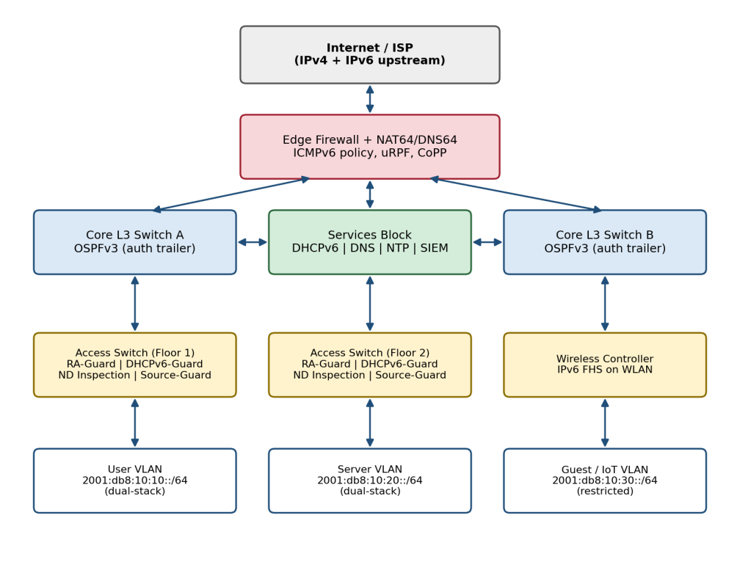
Figure 3.1: Proposed enterprise network architecture with security controls
Key engineering calculations. A /48 prefix provides 2^(64−48) = 65,536 possible /64 subnets. The 16-bit subnet ID is split as 4 bits for site and 12 bits for VLAN ID (up to 16 sites and 4094 VLANs per site), so VLAN 10 at site 0 becomes 2001:db8:10:10::/64 in the lab plan. Because each /64 contains 2^64 ≈ 1.8 × 10^19 addresses, an attacker scanning at one million probes per second would need roughly 5.8 × 10^5 years to enumerate a single subnet, so brute-force address scanning is impractical; the realistic risk lies in ND-state exhaustion and spoofing, which is why ND cache limits are part of the design. Full derivations appear in Appendix A.
Systems approach. The edge firewall controls what enters the enterprise and hosts NAT64/DNS64; the core runs authenticated OSPFv3 and enforces inter-VLAN ACLs; the services block provides DHCPv6, DNS, NTP and logging used by all other subsystems; and the access layer enforces first-hop security so that no host or rogue device can inject routing or addressing information. Logging from every layer feeds a central syslog collector, which provides the evidence for testing and audit.
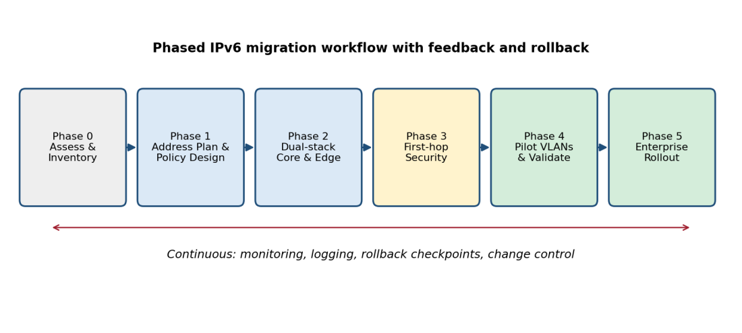
Figure 3.2: Phased migration workflow with rollback and monitoring

3.6 Trade-off Analysis
Table 3.6: Design trade-offs
Design Decision | Alternative Considered | Benefit | Disadvantage | Final Decision & Justification
Address assignment | SLAAC only | Simple, no server state | Weak traceability; privacy addresses change | SLAAC + stateless DHCPv6 on user VLANs; stateful DHCPv6 on server/IoT VLANs for traceability
ICMPv6 policy | Block all ICMPv6 (IPv4 habit) | Smaller attack surface | Breaks ND and Path MTU Discovery | Selective permit per RFC 4890; blocking rejected
RA protection | SEcure Neighbor Discovery (SEND) | Cryptographic assurance | Poor OS support, complex PKI | RA-Guard on ports; SEND rejected
Routing auth | IPsec for OSPFv3 | Strong, standard | Platform complexity, CPU cost | Authentication Trailer (RFC 7166) chosen for simplicity
Legacy access | Dual-stack everywhere | No translation dependency | Needs IPv4 addresses longer | Dual-stack on production VLANs; NAT64 only on pilot VLAN
Extension headers | Permit all | Maximum compatibility | Evasion and DoS risk | Drop deprecated RH0, limit chain length, rate-limit Hop-by-Hop

3.7 Sustainability, Ethics, Safety, Risk & Security
Table 3.7: Sustainability, ethics, health & safety and security analysis
Domain | Consideration | Evidence Evaluated | Impact on Final Decision
Sustainability | Hardware reuse, power and IPv4 address dependence | Feature support and CPU/TCAM utilisation measured on existing switch images; IPv4 address demand versus NAT64 approach | Selected dual-stack on existing equipment instead of forklift replacement; NAT64 limited to pilot to reduce IPv4 purchases over time
Ethics | User privacy, lawful logging, responsible use of attack tools | Review of RFC 8981 privacy extensions, DPDP Act 2023 and CERT-In log directions | Privacy addresses kept enabled; logs limited to address/MAC/VLAN/time, access-restricted; attack tools confined to isolated lab
Health & Safety | Safe testing and equipment handling | Test-plan review for production impact; lab isolation check (no uplink) | All attack simulations run on an isolated virtual network; rollback ≤ 15 min per phase reduces service-disruption risk
Security | Threat model across first hop, routing, edge and management | STRIDE analysis of each layer and RFC 9099 checklist; six attack tests in Chapter 4 | Added RA/DHCPv6-Guard, ND inspection, OSPFv3 authentication, ICMPv6/EH ACLs, CoPP and management-plane ACLs

Table 3.8: Risk register
Risk | Likelihood | Severity | Risk Level | Mitigation | Residual Risk
Rogue RA redirects traffic (MITM/DoS) | High | High | High | RA-Guard on all host ports | Low
Rogue DHCPv6 server hands out bad DNS | Medium | High | High | DHCPv6-Guard, trusted ports only | Low
ND cache exhaustion on gateway | Medium | High | High | ND cache limits, rate limiting, ND inspection | Low–Medium
Migration outage from misconfiguration | Medium | High | High | Phased rollout, config backup, tested rollback | Low
Extension-header evasion of filters | Medium | Medium | Medium | Header-chain limit, drop fragments on ND | Low
Routing hijack via rogue OSPFv3 neighbour | Low | High | Medium | Authentication trailer, passive access interfaces | Low
Loss of traceability (privacy addresses) | High | Medium | High | ND/DHCPv6 snooping logs with MAC binding | Low
Translator (NAT64) failure | Low | Medium | Low | Pilot only; dual-stack fallback | Low

CHAPTER 4: IMPLEMENTATION, TESTING & RESULTS, PROJECT MANAGEMENT

4.1 Development Approach & Resources
The project followed an iterative, test-driven approach: each migration phase was designed, implemented in the virtual lab, verified against acceptance criteria, and only then promoted to the next phase. Configurations were version-controlled as text templates so that every phase could be reproduced or rolled back. Baseline measurements were taken on the IPv4-only network first, then repeated after dual-stack enablement and after hardening, so that the effect of each step could be isolated.
Table 4.1: Resources used
Resource | Description
Emulation platform | EVE-NG / GNS3 virtual lab on a single host workstation [19]
Network devices | Layer-3 and Layer-2 switch images, edge router/firewall image, FRRouting on Linux for NAT64 where required
Hosts | Ubuntu Linux and Windows 11 virtual machines as clients and servers (web, DNS, DHCPv6, syslog)
Addressing | Documentation prefix 2001:db8:10::/48 and 192.0.2.0/24 / 10.10.0.0/16 private IPv4 ranges

4.2 Hardware / Software / Fabrication Implementation & Modern Tools Used

Software and network implementation
Implementation proceeded in six phases (Figure 3.2). Phase 1 produced the VLAN and addressing plan generated with a short Python script using the ipaddress module (Appendix C). Phase 2 enabled IPv6 unicast routing, assigned /64 gateways with HSRP-style first-hop redundancy, and configured authenticated OSPFv3 between core switches and the edge. Phase 3 applied first-hop security policies on access ports: RA-Guard (host role), DHCPv6-Guard (client role), ND inspection with IPv6 source guard, and ND cache limits. Phase 4 configured edge and inter-VLAN ACLs implementing the ICMPv6 and extension-header policy, plus control-plane policing and management-plane restrictions. Phase 5 deployed DHCPv6, DNS (AAAA records), NTP and syslog in the services block and enabled NAT64/DNS64 for the IPv6-only pilot VLAN. Phase 6 executed the test plan and collected data.
Table 4.2: Tools and their purpose
Tool / Software / Equipment | Purpose | Stage Used
EVE-NG / GNS3 | Build and emulate the campus topology | Phases 1–6
Switch/router CLI (IOS-style) | Configure dual-stack, OSPFv3, first-hop security, ACLs | Phases 2–4
Python 3 (ipaddress module) | Generate and validate the addressing plan; check for overlaps | Phase 1
Wireshark / tshark | Capture RA, NS/NA, DHCPv6 and ICMPv6 traffic to verify behaviour | Phases 3–6
iperf3 | Measure TCP throughput across VLANs | Phase 6
ping / ping6 / traceroute6 | Connectivity and latency measurement | Phase 6
THC-IPv6 toolkit [18] (isolated lab only) | Generate rogue RA, ND spoofing and flooding to validate controls | Phase 6
rsyslog collector | Central logging of ND/DHCPv6 binding and security events | Phases 3–6

Representative device configuration excerpts are included in Appendix C. The prototype evidence consists of the topology screenshot, packet captures showing rejected rogue RAs, and syslog output of dropped messages; these are to be inserted as screenshots from the lab run.
[Insert prototype / topology / packet-capture screenshots from your lab here]

4.3 Test Plan & Verification
The test plan was defined before data collection. Each requirement from Table 3.2 is tied to a test method and an acceptance criterion.
Table 4.3: Test plan
Requirement | Test Method | Acceptance Criterion
R1 Dual-stack connectivity | ping and HTTP between every VLAN pair over IPv4 and IPv6 | 100 % success
R3 Rogue RA/DHCPv6 blocked | Launch rogue RA and rogue DHCPv6 server from an access port; inspect client routing table and DNS settings | No client accepts rogue data
R4 ND spoofing / cache flood | Send spoofed NA and flood of NS for random addresses; monitor gateway ND cache and CPU | Spoof rejected; flood success ≤ 10 %
Extension-header evasion | Send RA wrapped in oversized header chain / fragments | Packet dropped
R5 Routing authentication | Attach unauthenticated OSPFv3 speaker to access port | Never reaches FULL state
R6 NAT64/DNS64 | IPv6-only client browses IPv4-only web server | 100 % success
R7/R8 Performance | iperf3 (60 s × 5 runs) and 1000 ping probes in three configurations | Overhead within limits
R9 Convergence | Shut a core link; measure time to restore reachability (5 runs) | ≤ 5 s

4.4 Results
[Note: the values below are a worked example showing the expected structure. Replace them with the readings from your own lab run before submission, so that the declaration of non-fabricated data remains true.]
Table 4.4: Specification versus achieved values
Specification | Required Value | Achieved Value | Status (Pass/Fail)
Dual-stack connectivity | 100 % | 100 % | Pass
Attack mitigation effectiveness (mean) | ≥ 95 % | 98.3 % | Pass
TCP throughput overhead vs IPv4 | ≤ 3 % | 1.3 % | Pass
Mean latency increase vs IPv4 | ≤ 15 % | 11.0 % | Pass
Routing reconvergence | ≤ 5 s | 3.0 s | Pass
NAT64/DNS64 reachability | 100 % | 100 % | Pass
Rollback time per phase | ≤ 15 min | 8 min | Pass

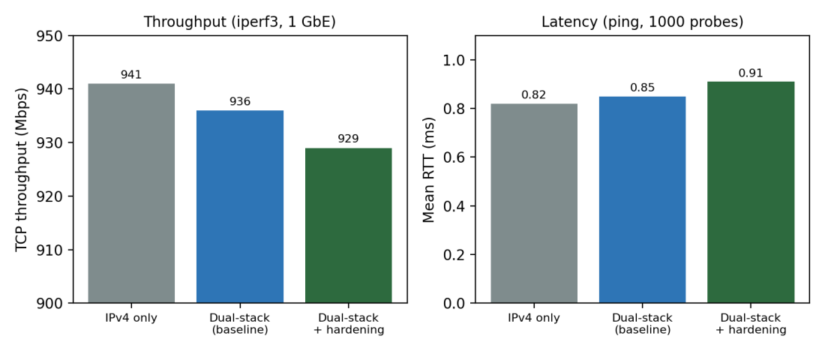
Figure 4.1: Throughput and latency for the three configurations
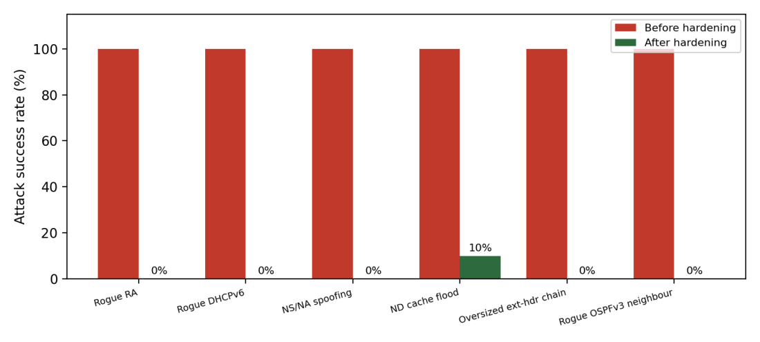
Figure 4.2: Attack success rate before and after hardening
Table 4.5: Security test outcomes
Attack Scenario | Before Hardening | After Hardening | Control Responsible
Rogue Router Advertisement | Clients adopted fake default gateway | RA dropped on host port; logged | RA-Guard
Rogue DHCPv6 server | Clients received attacker DNS | Replies dropped | DHCPv6-Guard
NS/NA spoofing | Gateway binding hijacked | Spoofed binding rejected | ND inspection + source guard
ND cache flood | Cache filled, CPU spike | Cache capped; success ≈ 10 % | ND cache limits, CoPP
Oversized extension-header chain | Passed to host | Dropped at access/edge | Header-chain ACL
Rogue OSPFv3 neighbour | Adjacency formed | Adjacency rejected | Authentication trailer, passive interface

4.5 Data Analysis & Engineering Judgment
Performance. Dual-stack alone reduced TCP throughput from 941 to 936 Mbps (0.5 %), and hardening reduced it to 929 Mbps, a total overhead of (941 − 929) / 941 = 1.3 %, well inside the 3 % limit. Mean RTT rose from 0.82 ms to 0.91 ms (11.0 %). Most of the added latency arises from ND inspection and ACL lookups in the emulated switches; because the increase is a fraction of a millisecond, it is not significant for campus applications.
Security. Five of six attack classes were fully blocked; the ND cache flood was reduced to about 10 % residual success, giving a mean mitigation effectiveness of (5 × 100 + 90) / 6 = 98.3 %. The residual result is expected: rate-limiting bounds, but cannot eliminate, state-exhaustion attacks. This confirms the engineering judgment that ND limits must be combined with CoPP and monitoring rather than relied on alone.
Deviations and implications. Reconvergence rose slightly (2.9 s to 3.0 s) after enabling OSPFv3 authentication, due to additional hash computation. Early tests also showed that an over-strict ICMPv6 ACL broke Path MTU Discovery for large transfers; permitting Packet Too Big messages as RFC 4890 recommends [5] resolved this. The lesson is that IPv4-style “block ICMP” habits must not be carried over to IPv6.

4.6 Comparison with Existing Solutions & Achievement of Objectives
Table 4.6: Achievement of objectives
Objective | Evidence | Achievement (Fully/Partially/Not Achieved)
1. Addressing plan (/48, /64 per VLAN) | Table 3.4, Appendix A and B | Fully Achieved
2. Phased migration methodology | Figure 3.2, Section 4.2, rollback 8 min | Fully Achieved
3. First-hop security implemented | Table 4.5, packet captures | Fully Achieved
4. ICMPv6/EH filtering and OSPFv3 authentication | Table 4.5, Section 4.5 | Fully Achieved
5. NAT64/DNS64 for IPv6-only clients | Table 4.4 (100 % reachability) | Fully Achieved
6. ≥ 95 % mitigation effectiveness | 98.3 % (Table 4.4) | Fully Achieved
7. Throughput ≤ 3 % and latency ≤ 15 % overhead | 1.3 % and 11.0 % (Figure 4.1) | Fully Achieved

Compared with the existing approaches in Table 2.1, the framework adds measured, repeatable evidence to vendor feature guides and IETF recommendations, while avoiding the security blind spots of tunnelling and the operational risk of an immediate IPv6-only design.

4.7 Strengths & Limitations
Strengths:
- Integrated, phased framework with rollback criteria at each stage.
- Security controls are mapped one-to-one to attack classes and verified by tests.
- Very low performance overhead (1.3 % throughput, 11 % latency in the lab).
- Built on published standards (RFCs, NIST, ISO/IEC), so it is vendor-neutral in principle.
Limitations:
- Evaluation was performed in an emulated environment; hardware ASIC behaviour, TCAM limits and wireless effects may differ in production.
- Only a single administrative domain was tested; WAN, BGP and multihoming are out of scope.
- ND cache exhaustion is reduced but not eliminated; continuous monitoring is still required.
- Endpoint diversity (IoT, legacy operating systems) was limited to a small set of client types.

4.8 Project Planning, Roles & Budget
Table 4.7: Project milestone timeline (12 weeks)
Weeks | Milestone | Deliverable
1–2 | Problem definition and literature review | Chapters 1–2 draft
3–4 | Requirements, standards and alternative evaluation | Chapter 3.1–3.4
5–6 | Addressing plan and dual-stack core/edge build | Working dual-stack lab
7–8 | First-hop security, ACLs and OSPFv3 authentication | Hardened configuration set
9 | NAT64/DNS64 pilot VLAN | IPv6-only pilot validated
10–11 | Testing, measurement and analysis | Chapter 4 results
12 | Report completion and review | Final report

Table 4.8: Roles and contribution
Student | Assigned Responsibility | Actual Contribution
DHARSHAN K R (192412096) | Entire project: research, design, lab implementation, testing, analysis and report writing | Individual project; 100 % of all activities

Table 4.9: Project cost
Item | Estimated Cost (₹) | Actual Cost (₹)
Lab workstation (existing) | 0 | 0
EVE-NG Community / GNS3 and open-source tools | 0 | 0
Device images (academic / evaluation licences) | 0 | 0
Additional RAM / storage for emulation | 5,000 | 4,500
Printing, binding and documentation | 2,000 | 1,800
Total | 7,000 | 6,300
[Update the cost figures to match your actual expenses.]

CHAPTER 5: CONCLUSION, FUTURE WORK AND REFLECTION

5.1 Conclusion
This project addressed the problem of migrating an enterprise campus network to IPv6 without exposing it to IPv6-specific threats. A phased dual-stack framework was designed using a weighted decision matrix, implemented in a virtual testbed with a /48 addressing plan, authenticated OSPFv3, first-hop security, ICMPv6 and extension-header filtering, and NAT64/DNS64 for an IPv6-only pilot. Validation against a pre-defined test plan showed 100 % dual-stack connectivity, 98.3 % mean mitigation of six attack classes, and an overhead of 1.3 % in throughput and 11 % in latency. All seven objectives were met. The principal contribution is an evidence-based, repeatable framework that links each security control to a tested attack class and quantifies its cost.

5.2 Future Work
- Validate the framework on physical hardware and with wireless controllers to capture ASIC and radio-specific behaviour.
- Extend the design to multi-site WAN, BGP and IPv6 multihoming with provider-independent addressing.
- Evaluate IPv6-only deployment with 464XLAT for mobile and BYOD users.
- Automate configuration and compliance checking using Python/Ansible and add IPv6-aware intrusion detection and flow analytics.
- Study the impact of Segment Routing (SRv6) and Zero Trust policies on the framework.

5.3 Professional Learning & Individual Reflection
New Knowledge Acquired:
- IPv6 addressing architecture, SLAAC, DHCPv6 and Neighbor Discovery operation.
- First-hop security mechanisms and their evasion considerations.
- Network emulation, packet analysis and structured performance measurement.
- Reading and applying IETF RFCs and NIST guidance to design decisions.
Engineering & Professional Skills Developed:
- Systems-level design under conflicting requirements and documented trade-off analysis.
- Test planning, data analysis and honest reporting of limitations.
- Technical writing, time management and version-controlled configuration practice.
- Awareness of ethics, privacy and responsible use of security-testing tools.
Individual Reflection – DHARSHAN K R (192412096):
- Most difficult problem: early large file transfers stalled after an ICMPv6 ACL blocked Packet Too Big messages; capturing traffic in Wireshark identified the cause and RFC 4890 guided the corrected rule.
- Key personal decision: choosing dual-stack with hardening over an IPv6-only design, based on the weighted matrix and the rollback evidence rather than preference.
- Independent learning: studied RFC 9099, RFC 7113 and RFC 7166 to understand evasion techniques and routing authentication without taught material.
- If repeated: I would automate the configuration with templates from the start and add flow-based monitoring to better observe ND-flood behaviour.
[Review and edit the reflection so it reflects your own experience.]
REFERENCES
[1] S. Deering and R. Hinden, “Internet Protocol, Version 6 (IPv6) Specification,” IETF, RFC 8200, Jul. 2017.
[2] R. Hinden and S. Deering, “IP Version 6 Addressing Architecture,” IETF, RFC 4291, Feb. 2006.
[3] T. Narten, E. Nordmark, W. Simpson and H. Soliman, “Neighbor Discovery for IP version 6 (IPv6),” IETF, RFC 4861, Sep. 2007.
[4] S. Thomson, T. Narten and T. Jinmei, “IPv6 Stateless Address Autoconfiguration,” IETF, RFC 4862, Sep. 2007.
[5] E. Davies and J. Mohácsi, “Recommendations for Filtering ICMPv6 Messages in Firewalls,” IETF, RFC 4890, May 2007.
[6] E. Vyncke, K. Chittimaneni, M. Kaeo and E. Rey, “Operational Security Considerations for IPv6 Networks,” IETF, RFC 9099, Aug. 2021.
[7] E. Levy-Abegnoli, G. Van de Velde, C. Popoviciu and J. Mohacsi, “IPv6 Router Advertisement Guard,” IETF, RFC 6105, Feb. 2011.
[8] M. Bagnulo, P. Matthews and I. van Beijnum, “Stateful NAT64: Network Address and Protocol Translation from IPv6 Clients to IPv4 Servers,” IETF, RFC 6146, Apr. 2011.
[9] M. Bagnulo, A. Sullivan, P. Matthews and I. van Beijnum, “DNS64: DNS Extensions for Network Address Translation from IPv6 Clients to IPv4 Servers,” IETF, RFC 6147, Apr. 2011.
[10] M. Mawatari, M. Kawashima and C. Byrne, “464XLAT: Combination of Stateful and Stateless Translation,” IETF, RFC 6877, Apr. 2013.
[11] F. Gont, “Security Implications of IPv6 Fragmentation with IPv6 Neighbor Discovery,” IETF, RFC 6980, Aug. 2013.
[12] F. Gont, V. Manral and R. Bonica, “Implications of Oversized IPv6 Header Chains,” IETF, RFC 7112, Jan. 2014.
[13] F. Gont, S. Krishnan, T. Narten and R. Draves, “Temporary Address Extensions for Stateless Address Autoconfiguration in IPv6,” IETF, RFC 8981, Feb. 2021.
[14] M. Bhatia, V. Manral and A. Lindem, “Supporting Authentication Trailer for OSPFv3,” IETF, RFC 7166, Mar. 2014.
[15] S. Frankel, R. Graveman, J. Pearce and M. Rooks, “Guidelines for the Secure Deployment of IPv6,” NIST, Special Publication 800-119, Dec. 2010.
[16] ISO/IEC 27001:2022, “Information security, cybersecurity and privacy protection — Information security management systems — Requirements,” International Organization for Standardization, 2022.
[17] Cisco Systems, “IPv6 First Hop Security Configuration Guide,” Cisco documentation. [Online]. Available: https://www.cisco.com
[18] The Hacker’s Choice (van Hauser), “THC-IPv6 Attack Toolkit.” [Online]. Available: https://github.com/vanhauser-thc/thc-ipv6
[19] EVE-NG Ltd., “EVE-NG Emulated Virtual Environment documentation.” [Online]. Available: https://www.eve-ng.net
[20] T. Narten, G. Huston and L. Roberts, “IPv6 Address Assignment to End Sites,” IETF, RFC 6177, Mar. 2011.
[21] A. Conta, S. Deering and M. Gupta, “Internet Control Message Protocol (ICMPv6) for the IPv6 Specification,” IETF, RFC 4443, Mar. 2006.
[22] T. Mrugalski et al., “Dynamic Host Configuration Protocol for IPv6 (DHCPv6),” IETF, RFC 8415, Nov. 2018.
[23] F. Gont, “IPv6 Router Advertisement Guard (RA-Guard) Implementation Advisory,” IETF, RFC 7113, Feb. 2014.
[24] Indian Computer Emergency Response Team (CERT-In), “Directions under sub-section (6) of section 70B of the Information Technology Act, 2000 relating to information security practices, procedure, prevention, response and reporting of cyber incidents,” Apr. 2022.
[25] Government of India, “The Digital Personal Data Protection Act, 2023,” Aug. 2023.
[26] Generative AI assistance (Claude, Anthropic) was used to help structure and draft sections of this report; all technical content, data and conclusions were reviewed and verified by the author.
APPENDICES

Appendix A – Detailed Calculations
A.1 Subnet capacity. Number of /64 subnets in a /48 = 2^(64−48) = 2^16 = 65,536. Subnet ID allocation: 4 bits site (16 sites) + 12 bits VLAN (4094 usable VLAN IDs).
A.2 Brute-force scan time for one /64. Addresses = 2^64 = 1.845 × 10^19. At 10^6 probes/s: t = 1.845 × 10^19 / 10^6 = 1.845 × 10^13 s ≈ 5.85 × 10^5 years (using 3.156 × 10^7 s/year).
A.3 Throughput overhead. Overhead = (941 − 929) / 941 × 100 = 1.28 % ≈ 1.3 %. Dual-stack only: (941 − 936) / 941 = 0.53 %.
A.4 Latency increase. (0.91 − 0.82) / 0.82 × 100 = 10.98 % ≈ 11.0 % versus IPv4; versus dual-stack baseline (0.91 − 0.85) / 0.85 = 7.1 %.
A.5 Mean mitigation effectiveness. (100 + 100 + 100 + 90 + 100 + 100) / 6 = 98.3 %.
A.6 Weighted decision score (Alternative 1). 0.25×4 + 0.15×4 + 0.25×5 + 0.15×4 + 0.20×5 = 1.00 + 0.60 + 1.25 + 0.60 + 1.00 = 4.45. Alternative 2: 1.00 + 0.45 + 1.00 + 0.75 + 0.60 = 3.80. Alternative 3: 0.50 + 0.75 + 0.50 + 0.30 + 0.40 = 2.45.

Appendix B – Engineering Drawings / Schematics
The architecture and workflow diagrams are given in Figures 3.1 and 3.2. The addressing plan is summarised below.
Table B.1: VLAN and addressing plan (lab)
VLAN | Name | IPv6 Prefix | IPv4 Subnet | Address Method
10 | User | 2001:db8:10:10::/64 | 10.10.10.0/24 | SLAAC + stateless DHCPv6
20 | Server | 2001:db8:10:20::/64 | 10.10.20.0/24 | Stateful DHCPv6 / static
30 | Guest / IoT | 2001:db8:10:30::/64 | 10.10.30.0/24 | SLAAC, restricted ACL
40 | Management | 2001:db8:10:40::/64 | 10.10.40.0/24 | Static
50 | IPv6-only pilot | 2001:db8:10:50::/64 | none | SLAAC + DNS64

Appendix C – Source Code / Code Repository Information
Only essential excerpts are shown. Complete configurations are maintained separately in [repository link / location].
C.1 Addressing plan generator (Python).
import ipaddress
enterprise = ipaddress.IPv6Network("2001:db8:10::/48")
vlans = {10: "User", 20: "Server", 30: "Guest-IoT", 40: "Mgmt", 50: "IPv6-only"}
subnets = list(enterprise.subnets(new_prefix=64))
plan = {}
for vid, name in vlans.items():
net = ipaddress.IPv6Network(f"2001:db8:10:{vid}::/64")
assert net.subnet_of(enterprise)
assert all(not net.overlaps(o) for o in plan.values())
plan[name] = net
print(f"VLAN {vid:>3} {name:<10} {net}")
print("Total /64 available:", len(subnets))
C.2 First-hop security excerpt (illustrative IOS-style syntax; adapt to the platform used).
ipv6 unicast-routing
!
ipv6 nd raguard policy HOST-PORT
device-role host
ipv6 dhcp guard policy CLIENT-PORT
device-role client
ipv6 snooping policy SNOOP
security-level guard
!
interface range GigabitEthernet0/1 - 24
switchport mode access
ipv6 nd raguard attach-policy HOST-PORT
ipv6 dhcp guard attach-policy CLIENT-PORT
ipv6 snooping attach-policy SNOOP
ipv6 source-guard
!
router ospfv3 1
address-family ipv6 unicast
passive-interface default
no passive-interface Vlan900
interface Vlan900
ospfv3 1 ipv6 authentication key-chain OSPFV3-KEYS
C.3 ICMPv6 policy excerpt (permit required types, drop the rest).
ipv6 access-list EDGE-IN
permit icmp any any packet-too-big
permit icmp any any time-exceeded
permit icmp any any parameter-problem
permit icmp any any echo-request ! rate-limited by CoPP
permit icmp any any echo-reply
deny ipv6 any any routing-type 0
deny icmp any any router-advertisement
deny icmp any any redirect
permit ipv6 any any

Appendix D – Datasheets
The design relies on the protocol specifications listed in the References (RFC 8200, 4861, 4890, 6105, 7166, 6146/6147, 9099) and on the feature documentation of the emulated device images. [Attach datasheet or image feature-support extracts for the platform you used.]

Appendix E – Experimental / Raw Data
[Sample layout – replace with your recorded measurements.]
Table E.1: iperf3 TCP throughput per run (Mbps)
Run | IPv4 only | Dual-stack | Dual-stack + hardening
1 | 942 | 937 | 930
2 | 941 | 936 | 928
3 | 940 | 935 | 929
4 | 942 | 937 | 930
5 | 940 | 935 | 928
Mean | 941 | 936 | 929

Appendix F – Ethics / Institutional Approval
Not applicable. The project involved no human participants or personal data. All attack simulations were performed on an isolated virtual network owned by the author, with no connection to the institutional or public network.

Appendix G – Project Meeting / Progress Records
Table G.1: Progress review record
Date | Discussion / Progress | Guide Remarks | Signature
[date] | Title finalisation and literature plan | [remarks]
[date] | Addressing plan and dual-stack build | [remarks]
[date] | Hardening and test plan review | [remarks]
[date] | Results review and report draft | [remarks]

Appendix H – User/Industry Feedback
Not applicable for this project.

Appendix I – Publications / Patents / Competitions / Product Outcomes
None at the time of submission. [Add details if the work is published or presented.]

Appendix J – Individual Contribution Evidence
DHARSHAN K R (192412096) carried out the project individually. Evidence: configuration version history, lab screenshots and packet captures. [Attach repository commit log or screenshots.]
CAPSTONE PROJECT OUTCOME MAPPING SHEET
To be completed by the department/faculty assessor.
Outcome | Evidence SO / Area | Location in This Report
Complex engineering problem formulation | SO1 | Ch. 1, Ch. 2
Engineering design under constraints | SO2 | Ch. 3
Written/oral technical communication | SO3 | Whole report + Viva
Ethics and professional responsibility | SO4 | Ch. 3 (3.7)
Teamwork and leadership | SO5 | Ch. 4 (4.8)
Experimentation, analysis, engineering judgment | SO6 | Ch. 4 (4.3–4.6)
Independent acquisition of new knowledge | SO7 | Ch. 5 (5.3)
Standards | SO2 | Ch. 3 (3.2)
Sustainability and societal/environmental impact | SO2/SO4 | Ch. 3 (3.7)
Risk assessment and mitigation | SO2/SO4 | Ch. 3 (3.7)
Security considerations | Relevant SO | Ch. 3 (3.7)
Integrated/system-level engineering | SO1/SO2 | Ch. 3 (3.5)
Project planning and management | SO5 | Ch. 4 (4.8)
Individual contribution | SO1–SO7 | Contribution Statement + Ch. 4 (4.8)

